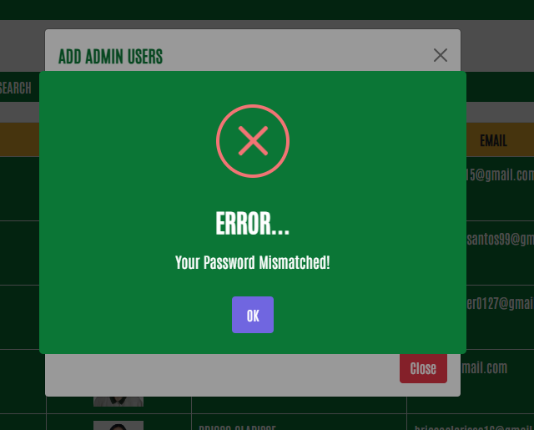

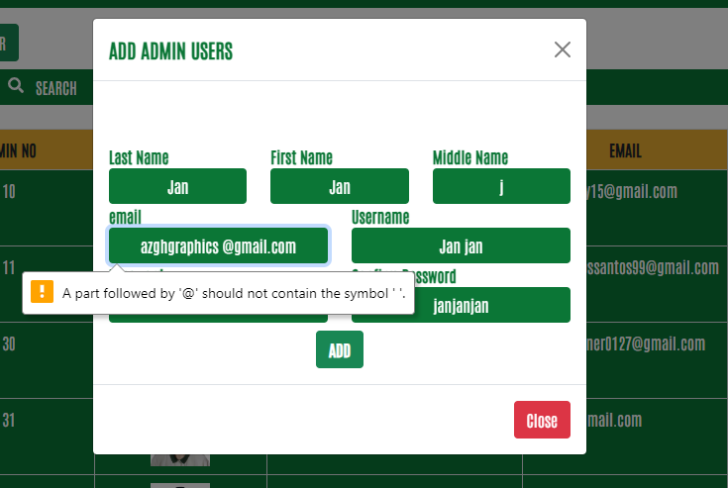

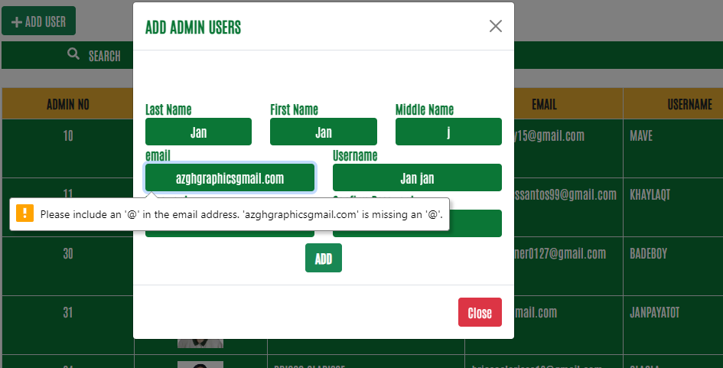

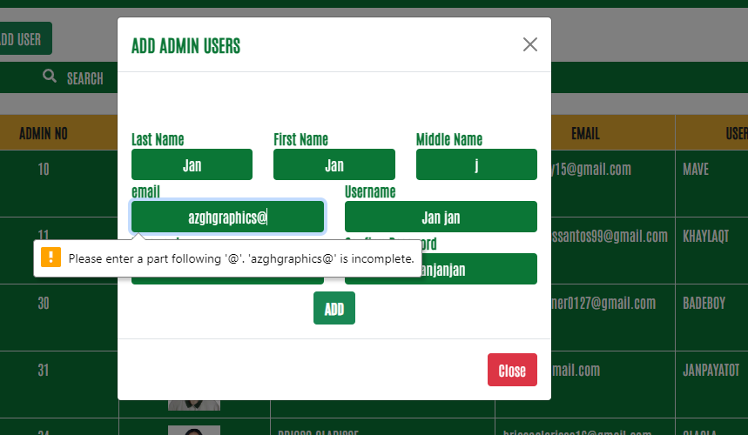

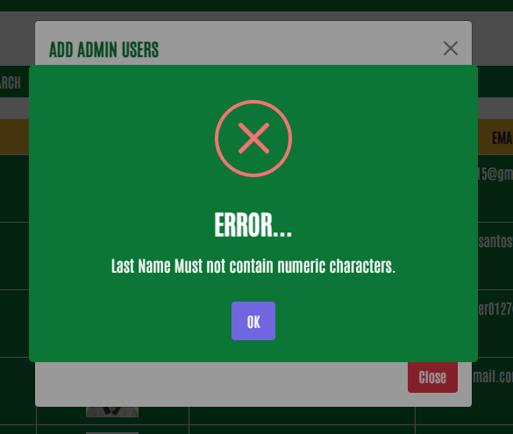

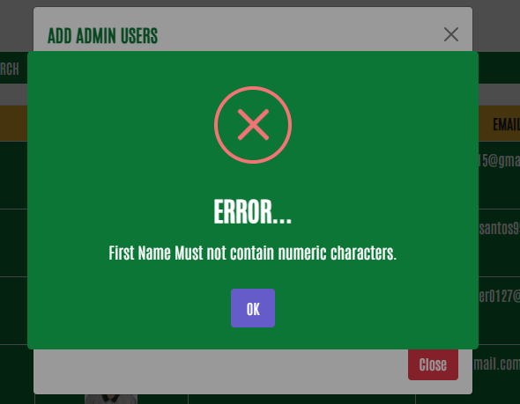

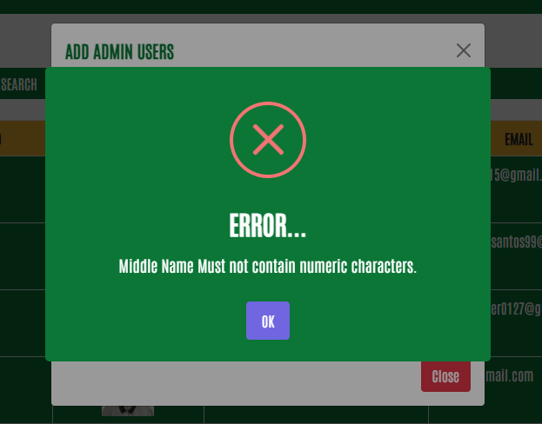

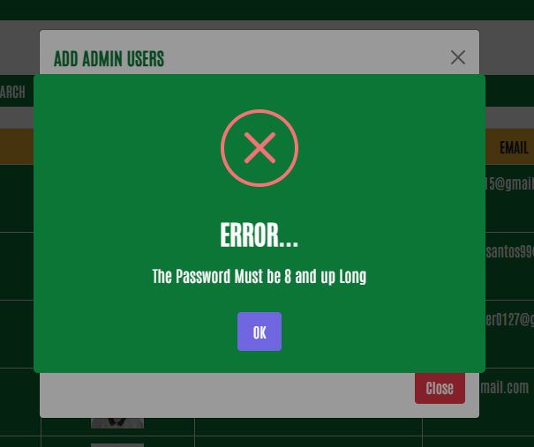

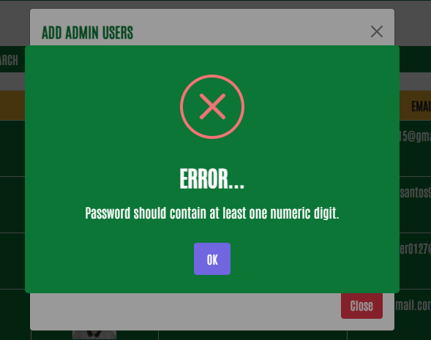

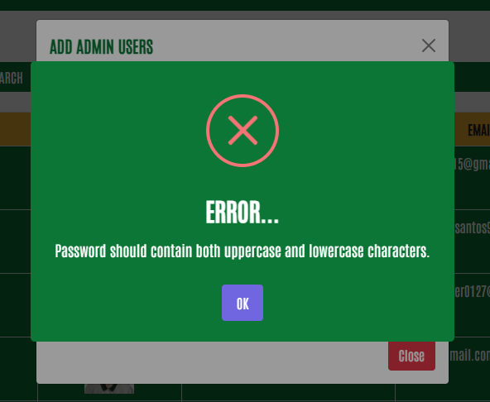

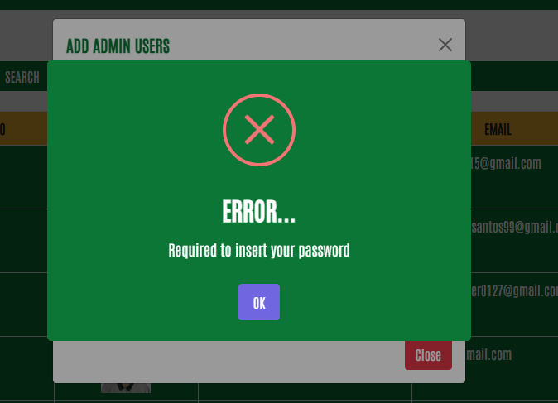

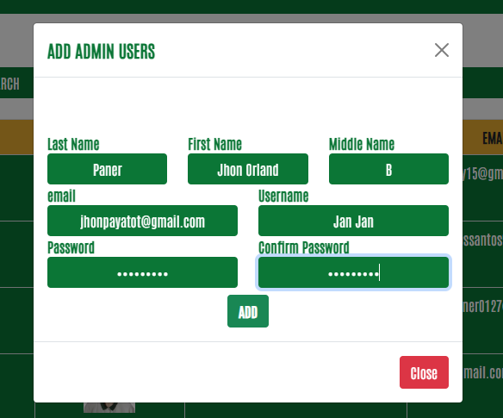

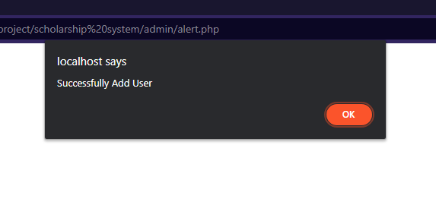

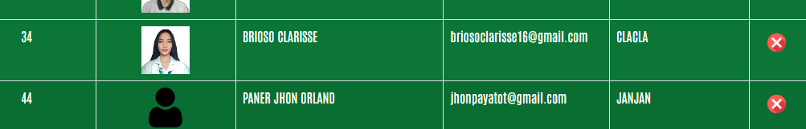

<!-- add product -->

<div class="modal fade" id="addUser" tabindex="-1" aria-labelledby="exampleModalLabel" aria-hidden="true">

<div class="modal-dialog modal-dialog-centered modal-dialog-scrollable">

<div class="modal-content">

<div class="modal-header">

<h5 class="modal-title text-uppercase" id="exampleModalLabel">Add Admin Users</h5>

<button type="button" class="btn-close" data-bs-dismiss="modal" aria-label="Close"></button>

</div>

<div class="modal-body">

<form id="registrationForm" onsubmit="validateForm(event)" name="frmReg" method="post" class="mt-5">

<div class="row ">

<div class="col-md-4 col-xs-4">

<label >Last Name</label>

<input type="text" name="lastname" id="lastname" required class="form-control text-center" placeholder="last name" />

</div>

<div class="col-md-4 col-xs-4">

<label>First Name</label>

<input type="text" name="fname" id="fname" required class="form-control text-center" placeholder="first name" />

</div>

<div class="col-md-4 col-xs-4">

<label >Middle Name</label>

<input type="text" name="mname" id="mname" required class="form-control text-center" placeholder="middle name" />

</div>

<div class="col-md-6 col-xs-4">

<label>email</label>

<input type="email" name="email" id="email" required class="form-control text-center" placeholder="email" />

</div>

<div class="col-md-6 col-xs-4">

<label>Username</label>

<input type="text" name="username" required class="form-control text-center" placeholder="Username" />

</div>

<div class="col-md-6 col-xs-4">

<label>Password</label>

<input type="password" name="password" id="password" required class="form-control text-center" placeholder="password" />

</div>

<div class="col-md-6 col-xs-4">

<label>Confirm Password</label>

<input type="password" name="cpass" required class="form-control text-center" placeholder="confirm password" />

</div>

<div class="col-md-12 text-center">

<button type="submit" name="AddUser" class="btn btn-outline-success mt-2 text-right fw-bold" onclick="return valReg();"> ADD</button>

</div>

</div><!-- end of row -->

</form>

</div><!--end of modal body -->

<div class="modal-footer">

<button type="button" class="btn btn-danger" data-bs-dismiss="modal">Close</button>

</div>

</div>

</div>

</div>

<!-- end of add product -->

____________________________________________________________________________

function valReg(){

//end of firstname

if (frmReg.fname.value == "")

{

Swal.fire({

background: '#0B7636',

color: '#fff',

icon: 'error',

title: 'ERROR...',

allowOutsideClick: false,

allowEscapeKey:false,

text: 'Required to write your First Name'

})

frmReg.fname.focus();

return false;

}

//end of username

if (frmReg.mname.value == "")

{

Swal.fire({

background: '#0B7636',

color: '#fff',

icon: 'error',

allowOutsideClick: false,

allowEscapeKey:false,

title: 'ERROR...',

text: 'Required to write your Middle Name'

})

frmReg.mname.focus();

return false;

}

//end of contact

if (frmReg.password.value == "")

{

Swal.fire({

background: '#0B7636',

color: '#fff',

icon: 'error',

title: 'ERROR...',

allowOutsideClick: false,

allowEscapeKey:false,

text: 'Required to insert your password'

})

frmReg.password.focus();

return false;

}

/*end of password*/

if (frmReg.cpass.value == "")

{

Swal.fire({

background: '#0B7636',

color: '#fff',

icon: 'error',

title: 'ERROR...',

allowOutsideClick: false,

allowEscapeKey:false,

text: 'Required to Confirm your Password'

})

frmReg.cpass.focus();

return false;

}

/*end of confirm password*/

if ((frmReg.password.value).length < 8)

{

Swal.fire({

background: '#0B7636',

color: '#fff',

icon: 'error',

title: 'ERROR...',

allowOutsideClick: false,

allowEscapeKey:false,

text: 'The Password Must be 8 and up Long'

})

frmReg.password.focus();

return false;

}

if (frmReg.password.value != frmReg.cpass.value)

{

Swal.fire({

background: '#0B7636',

color: '#fff',

icon: 'error',

title: 'ERROR...',

allowOutsideClick: false,

allowEscapeKey:false,

text: 'Your Password Mismatched!'

})

frmReg.password.value="";

frmReg.cpass.value="";

frmReg.password.focus();

return false;

}

return true;

}

function validateForm(event) {

// Ito ay para maiwasan ang pagsu-submit ng form at mag-refresh ang page

// Kunin ang mga input field values

var password = document.getElementById('password').value;

var email = document.getElementById('email').value;

var lastname = document.getElementById('lastname').value;

var fname = document.getElementById('fname').value;

var mname = document.getElementById('mname').value;

// Simpleng validation

if (email === '' || lastname === '' || fname === '' || mname === '') {

alert('Please fill in all fields.');

return;

}

// Numeric validation

if (!isNumeric(password)) {

Swal.fire({

background: '#0B7636',

color: '#fff',

icon: 'error',

title: 'ERROR...',

allowOutsideClick: false,

allowEscapeKey:false,

text: 'Password should contain at least one numeric digit.'

})

return false;

}

// Uppercase and lowercase validation

if (!hasUppercaseLowercase(password)) {

Swal.fire({

background: '#0B7636',

color: '#fff',

icon: 'error',

title: 'ERROR...',

allowOutsideClick: false,

allowEscapeKey:false,

text: 'Password should contain both uppercase and lowercase characters.'

})

return false;

}

if (!validateEmail(email)) {

alert('Please enter a valid email address.');

return;

}

if (!validateName(lastname)) {

Swal.fire({

background: '#0B7636',

color: '#fff',

icon: 'error',

title: 'ERROR...',

allowOutsideClick: false,

allowEscapeKey:false,

text: 'Last Name Must not contain numeric characters.'

})

return false;

}

if (!validatelast(fname)) {

Swal.fire({

background: '#0B7636',

color: '#fff',

icon: 'error',

title: 'ERROR...',

allowOutsideClick: false,

allowEscapeKey:false,

text: 'First Name Must not contain numeric characters.'

})

return false;

}

if (!validatemname(mname)) {

Swal.fire({

background: '#0B7636',

color: '#fff',

icon: 'error',

title: 'ERROR...',

allowOutsideClick: false,

allowEscapeKey:false,

text: 'Middle Name Must not contain numeric characters.'

})

return;

}

// Dito ay maaari mong magdagdag ng iba pang validation checks gaya ng email format, password length, atbp.

// Kung na-validate na ang form, maaari mo ring ipasa ang data sa server o gawin ang ibang mga kailangang hakbang.

// Halimbawa:

var formData = {

email: email,

password: password,

lastname: lastname,

fname: fname,

mname: mname

};

console.log(formData); // Ito ay isang halimbawa lamang, maaari mong ipasa ang data sa server gamit ang AJAX o iba pang paraan.

// Maari kang magdagdag ng iba pang code o logic na kailangan mo pagkatapos ng validation.

}

function validateEmail(email) {

var re = /^[^\s@]+@[^\s@]+\.[^\s@]+$/;

return re.test(email);

}

function isNumeric(value) {

return /\d/.test(value);

}

function hasUppercaseLowercase(value) {

return /[a-z]/.test(value) && /[A-Z]/.test(value);

}

function validateName(lastname) {

var regex = /^[a-zA-Z\s]*$/; // Regular expression na nag-a-allow ng mga letra at espasyo lamang

return regex.test(lastname);

}

function validatelast(fname) {

var regex = /^[a-zA-Z\s]*$/; // Regular expression na nag-a-allow ng mga letra at espasyo lamang

return regex.test(fname);

}

function validatemname(mname) {

var regex = /^[a-zA-Z\s]*$/; // Regular expression na nag-a-allow ng mga letra at espasyo lamang

return regex.test(mname);

}